

0

IO



|  |  |  |  |
| --- | --- | --- | --- |
| Receipt Number  IOE8776057640 | | Case Type  1129 - PETITION FOR A NONIMMIGRANT WORKER | |
| Received Date  06/30/2022 |  | EMERGTECH BUSINESS SOLUTIONS INC | |
| Notice Date  04/04/2024 | **Page**  1 of 2 | Beneficiary A131 290 482  SURAM, UDAY KUMAR | |
| EMERGTECH BUSINESS SOLUTIONS INC 35345 W 10 MILE ROAD 243  FARMINGTON MI 48335 | | | Notice Type: Approval Notice  Class: HIB  Valid from 04/04/2024 to 09/30/2025 |
| The above petition and accompanying request for a change of status have been approved. The status of the named beneficiary(ies) in this classification is valid as indicated on the 1-94 attached below. The beneficiary(ies) can work for the petitioner pursuant to this approval notice, but only as detailed in the petition and during the petition validity period indicated above, unless otherwise authorized by law. Changes in employment or training may require you to file a new Form I-129, Petition for a Nonimmigrant Worker.  The dates in the I-94 attached below might not be for the same dates as the petition validity dates above because the I-94 below may contain a grace period of up to 10 days before and up to 10 days after the petition validity period for the following classifications: CW-1, E-1, E-2, E-3, H-IB, H-2B, H-3, L-IA, L- lB, O-1, O-2, P-1, P-IS, P-2, P-2S, P-3, P-3S, TN-1, and TN-2. An I-94 for H-2A nonimmigrants may contain a grace period of up to one week before and 30 days after the petition validity period. However, the beneficiary(ies) may not work during such grace periods, unless otherwise authorized by law. The decision to grant a grace period and the length of the granted grace period is discretionary, final, and cannot be contested on motion or appeal. Please contact the IRS with any questions about tax withholding.  The petitioner should keep the upper portion of this notice. The lower portion should be given to the beneficiary(ies). The beneficiary(ies) should keep the right part (the 1-94 portion) with his or her other Forms 1-94, Arrival-Departure Record. The I-94 portion should be given to the U.S. Customs and Border Protection when he or she leaves the United States. The left part is for his or her records. A person granted a change of status who leaves the U.S. and is not visa-exempt must normally obtain a visa in the new classification before returning. The left pan can be used when applying for the new visa. If a visa is not required, he or she should present it, along with any other required documentation, when applying for reentry based on this approval notice at a port of entry or pre-flight inspection station. The petitioner may also file Form 1-824, Application for Action on an Approved Application or Petition, to request that we notify a consulate, port of entry, or pre-flight inspection office of this approval.  The approval of this petition does not guarantee that the beneficiary(ies) will be found to be eligible for a visa, for admission to the United States (if traveling abroad and seeking re-admission), or for a subsequent extension of stay, change of status, or adjustment of status. | | | |
| Please see the additional information on the back. You will be notified separately about any other cases you filed. | | | |
| **UbCIS encourages you to** sign **up for a U6LIS online account. To learn more about creating an account and the** benefits, **go to https://**  [**www.uscis.gov/file-online.**](http://www.uscis.gov/file-online) | | | |
| Texas Service Center  U.S. CITIZENSHIP & IMMIGRATION SVC  6046 N Belt Line Rd., STE 110 Irving TX 75038-0012  **USCIS Contact Center:** [**www.uscis.gov/contactcenter**](http://www.uscis.gov/contactcenter) | | | |

#### Detach This Half for Personal Records

**Receiptf** IOE8776057640

I-944 008179674 85

NAME SURAM, UDAY KUMAR

CLASS H1B

**VALID FROM** 04/04/2024 **UNTIL** 10/10/2025

#### PETITIONER

**EMERGTECH** BUSINESS SOLUTIONS INC 38345 W 10 **MILE** ROAD 243

FARMINGTON MI 48335

008179674 85

**Receipt Number** IOE8776057640

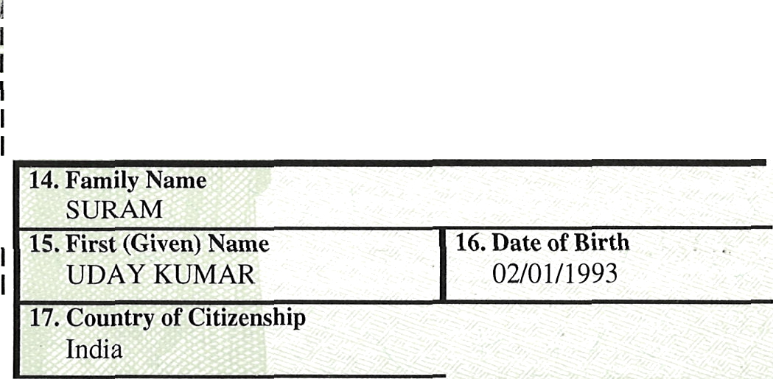

US **Citizenship and Immigration** Services

!

I

**194 Departure** Record

**Petitioner: EMERGTECH** BUSINESS SOLUTIONS INC

**14. Family Name**

SURAM

**15. First (Given) Name**

UDAY KUMAR

**17. Country of Citizenship**

India

**16. Date of Birth**

02/01/1993

**1**

FOf2M I-797A fif2EV. OO/O4/1GJ



0

0

0

|  |  |  |
| --- | --- | --- |
| Receipt Number  IOE8776057640 | | Case Type  1129 - PETITION FOR A NONIMMIGRANT WORKER |
| Received Date  06/30/2022 | Priority Date | EMERGTECH BUSINESS SOLUTIONS INC |
| Notice Date  04/04/2024 | Page  2 of 2 | Beneficiary A 131 290 482  SURAM, UDAY KUMAR |
| **THIS NOTICE IS NOT A** YISA **AND MAY NOT BE** USED **IN PLACE OF A** VISA.  The Small Business Regulatory Enforcement and Fairness Act established the Office of the National Ombudsman (ONO) at the Small Business Administration. The ONO assists small businesses with issues related to federal regulations. If you are a small business with a comment or complaint about regulatory enforcement, you may contact the ONO at [www.sba.gov/ombudsman](http://www.sba.gov/ombudsman) or phone 202-205-2417 or fax 202-481-5719.  **NOTICE:** Although this application or petition has been approved, USCIS and the U.S. Depanment of Homeland Security reserve the right to verify this information before and/or after making a decision on your case so we can ensure that you have complied with applicable laws, rules, regulations, and other legal authorities. We may review public information and records, contact others by mail, the internet or phone, conduct site inspections of businesses and residences, or use other methods of verification. We will use the information obtained to determine whether you are eligible for the benefit you seek. If we find any derogatory information, we will follow the law in determining whether to provide you (and the legal representative listed on your Form G-28, if you submitted one) an opportunity to address that information before we make a formal decision on your case or start proceedings. | | |
| Please see the additional information on the back. You will be notified separately about any other cases you filed. | | |
| USCIS **encourages you to sign up for a** USCIS **ontine account. 'l'o learn more about creating an account and the** benefits, go **to https://**  [www.uscis.gov/file](http://www.uscis.gov/file) online. | | |
| Texas Service Center  U.S. CITIZENSHIP & IMMIGRATION 5VC  6046 N Belt Line Rd., STE 110 Irving TX 75038-0012  USCIS Contact Center: [www.uscis.gov/contactcenter](http://www.uscis.gov/contactcenter) | | |



## R ENTIONALLY LEFT BLANK

**I-944**

## N&NIEENTIONALLY LEFT BLANK

#### CLASS

**vI¥RRB0QNQJJ@LEFTBLANK**

# PBFtgDbREHNALLY LEFT BLANK INTENTIONALLY LEFT BLANK

PLEASETEAROFPFOhMI90PRWTEDBELONANDSTAPLET0ORTGWAL*O4DA¥AILABLF

## ; INTENTIONALLY LEFT BLANK

### Recei oNALLY LEFT BLANK

I US **Citizenship and Immigration** Services

### I INTENTIONALLY LEFT BLANK

I194 Departure Record

IPetiti **ENTIONALLY LEFT BLANK**

1 14. **I''am'l**

N

### INTENTIONALLY LEFT BLANK



15. First (Given) Name 16. Date of Birth

# INTENTIONALLY L FT BLANK

1 17. Country of Citizenship



